1a. 0.7538961

1b. 0.7053127

1d. 0.7650897

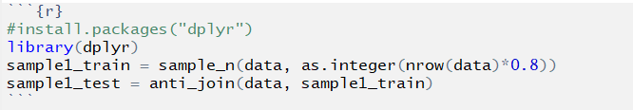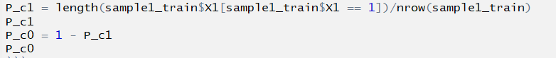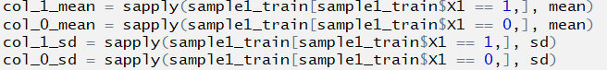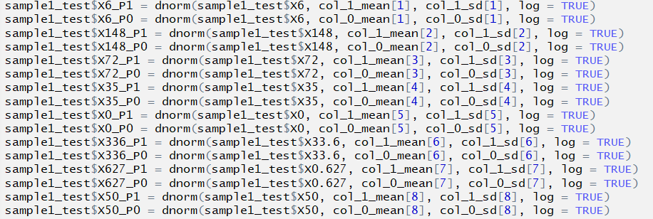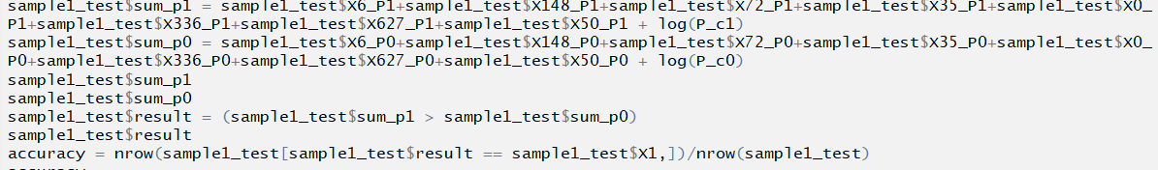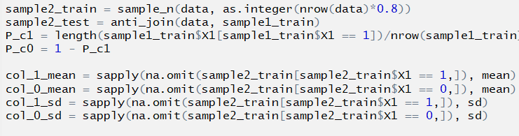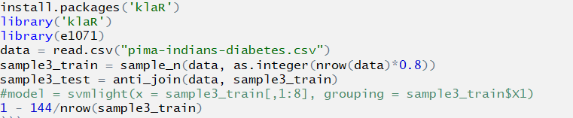

|  |  |  |
| --- | --- | --- |
| x | Method | Probability |
| 1 | Gaussian + untouched | 0.52354 |
| 2 | Gaussian + stretched | 0.83115 |
| 3 | Bernoulli + untouched | 0.83375 |
| 4 | Bernoulli + stretched | 0.79005 |
| 5 | 10 trees + 4 depth + untouched | 0.10315 |
| 6 | 10 trees + 4 depth + stretched | 0.75810 |
| 7 | 10 trees + 16 depth + untouched | 0.10035 |
| 8 | 10 trees + 16 depth + stretched | 0.96660 |
| 9 | 30 trees + 4 depth + untouched | 0.10205 |
| 10 | 30 trees + 4 depth + stretched | 0.79535 |
| 11 | 30 trees + 16 depth + untouched | 0.10115 |
| 12 | 30 trees + 16 depth + stretched | 0.97385 |

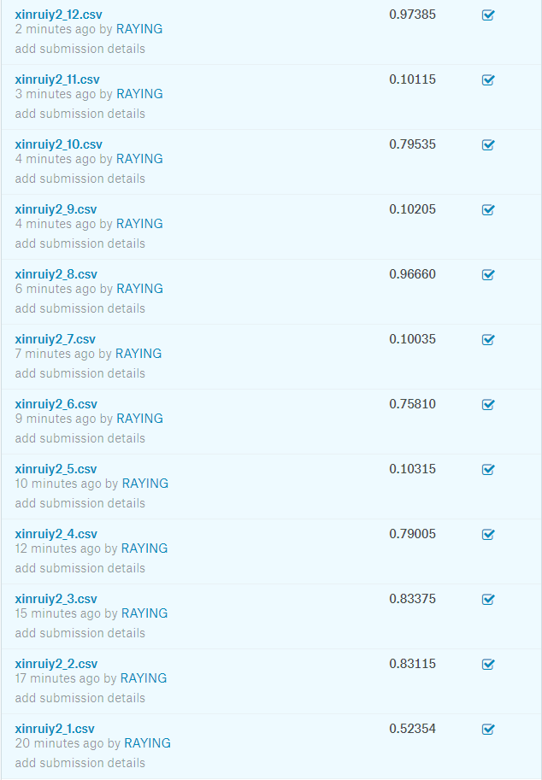

Gaussian + untouched : 

Bernoulli + Untouched:

Gaussian + Stretched: 

Bernoulli + Stretched:

